# Annual Vol ume of

THE L.AWS

# of f estern N igeria .

1964

## containing

the Laws of Western Nigeria

and Subsidiary Legislation made thereunder

**PRICE THREE GUINEAS**

LOS A1'1Gli::.:i..ES COUN.nl

LAW LIBRARY.



W,N,L.N. 35 of 1964

*The Local Government Lmv* {Co;,, *68)*

CONTROL OF DRUMMING ADOPTIVE BYE-LAWS ORDER, 1956

IJEBU IMUSIN PROVISIONAL AUTHORITY

DATE OF COMMENCEMENT: 27TH FEBRUARY, 1964

Notice is hereby given that in exercise of the powers Conferred upon the Ijebu Imusin Provisional Authority by sections 83 (2) and 276 of the Local Government Law, Cap. 68, the Ijebu Imusin Provisional Authority in accordance with section 83 (3) *( a)* of the said Law has resolved at its meeting

held on the 3rd day of August, 1963, that the Control of Drumming Adoptive W,R.L,N, 13 Bye-bws Order, 1956 as amended by W,R,L,N, 297 of 1957 be adopted of 1956, substituting the following for the First and Third Schedules thereof :---'--

FIRST SCHEDULE

Sakara Apala Batakoto

Kcte or Agasa

Ashiko Juju

Iya-ilu or Dundun Mambo /Agidigbo

THIRD SCHEDULE

*Description of Drum Period*

For any period between 6 a.m. and 6 p.m. For any period between 6. p.m. and 6 a.m. For any period between 6 a.m. and 6 p.m. For any period between 6 p.m. and 6 a.rn. For any period between 6 a.m. and 6 p.m. For any Feriod between 6 p.m. and 6 a.m. For any period between 6 a.m. arid 6 p.m. For any period between 6 p.m. and 6 a.m. For any period between 6 a.m. and 6 p.m. For any period between 6 p.m. and 6 a.m. For any period between 6 a.m. and 6 p.m. For any period between 6 p.m. and 6 a.m.

*Fees*

*s d*

10 0

10 0

10 0

10 0

10 0

10 0

10 0

10 0

10 0

10 0

10 0

10 0

or Dundun

For any period between 6 a.m. and 6 p.m. For any period between 6 p.m. and 6 a.m.­ For any period between 6 a.m. and 6- p.m. For any period between 6 p.m. and 6 a.m.

10 0

10 0

10 0

'" 10 0

DATED this 7th day of August, 1963.

M.A. SEMAKO)

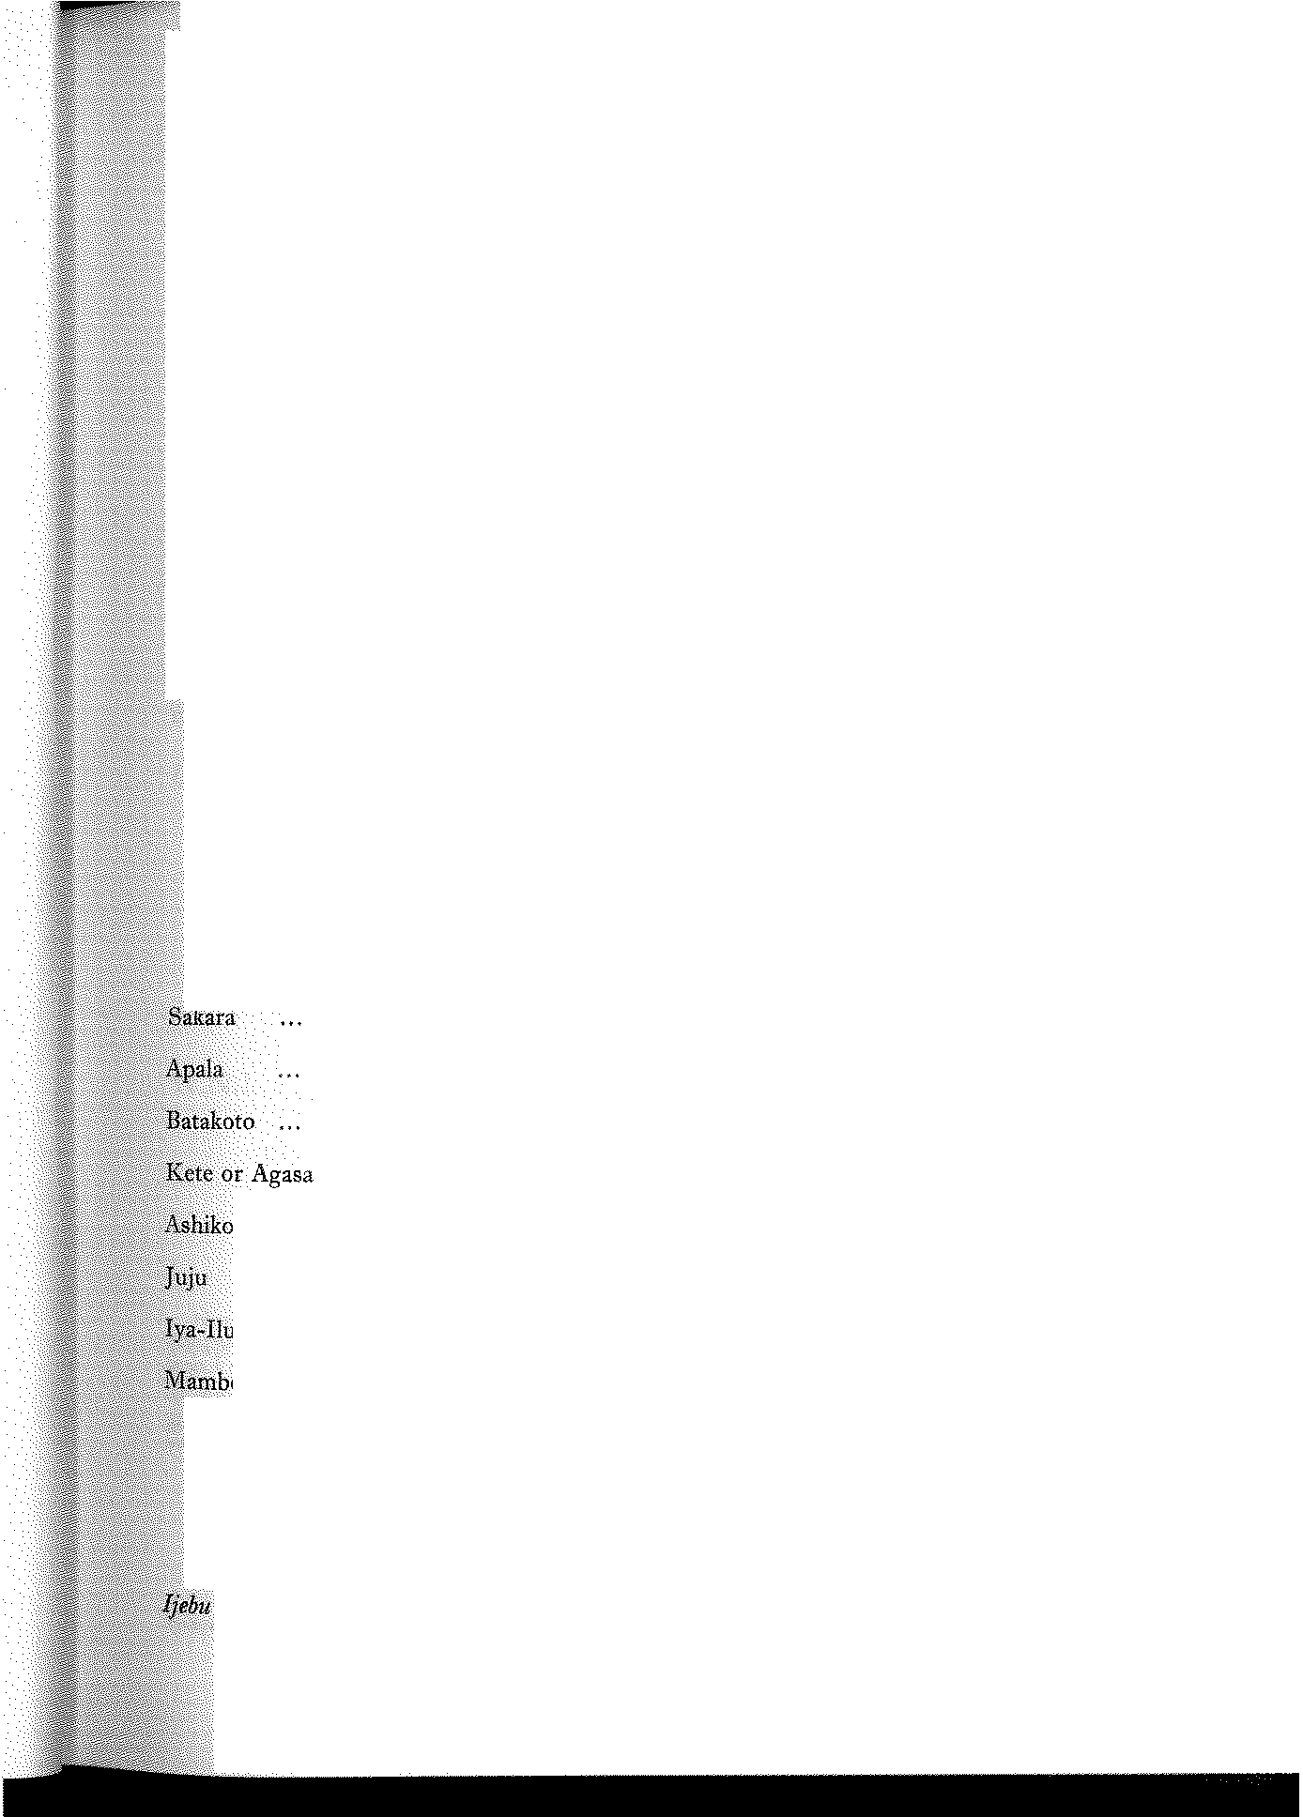

*Secretary / Treasurer,*

*Imusin Prouisi'onal Authority*

D. A. JA!YEOLA-ADEBOYEJO II,

*Chairman,*

*Iiebu lmusin Provisional Authority*